Tyler Stephens

Code creating the Databases used later in the project.

In this query the database table Order Item only displays datasets where the Price of the Item purchased is equal to 50.00 dollars.

In this query the database table Retail Order where the Year of the Order is not in 2017.

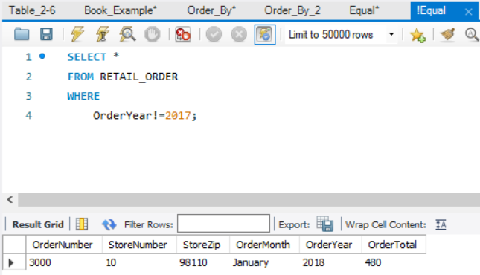

In this query the database table Order Item is ordered by the prices of the items in question.

In this query the database table Order Item is ordered by the two columns of Price and Extended price where we first order by the original price, then further order dataset by the extended price.

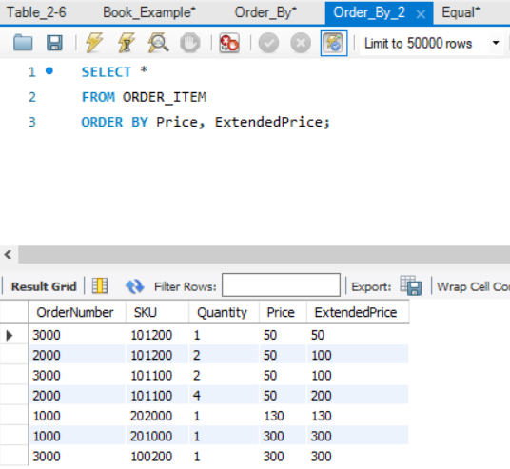

In this query the database table the SKU data is displaying the number of Products listed in the SKU description by Department. Basically its listing the number of products per department.

In this query the database table the SKU data is displaying the number of Products listed in the SKU description by Department. But we also narrow it down even more to where we only display what Department has more than 5 items in it.

In this query the database table we Join together two table Retail order and Order Item to display a larger table which is a combination of the two.

In this query the database table we Join together two table Retail order and Order Item and we also narrow down the table to only display the number of orders by how many items they have ordered. So we have it where four orders only ordered one item and only one order ordered four items.

